Title of the paper

Name and surname1, Name and surname1, Name and Surname2, Name and surname3

Organization1; Organization1; Organization3

|  |  |  |
| --- | --- | --- |
| Keywords: |  | Abstract |
| Keyword1  Keyword2  Keyword3  Keyword4  Keyword5 |  | Use the "Abstract and Keywords" style to write abstracts and keywords. Abstract is limited to a maximum of 250 words, while keywords are limited to 5 terms. |

# Chapters and text

Use this template to write a paper. For each of the text formats, use the predefined styles that are loaded on the Quick Assess Toolbar within the Home option.

Use the “Chapter Title” style for chapter titles and the “Subchapter Title” style for subchapters, both styles automatically number chapter titles and subheadings when they are selected. Use the “Text format” style when writing text. The paper is written in English and should be 6 to 10 pages long.

# Figures and tables

## Figures

When inserting an image into work, it must be centred, while using the "Figures caption" style for the image title, and the "Sources" style source reference must also be centred. When inserting images or graphs, make sure they are of high quality so that readers can clearly understand them. Images and graphs can be in colour or black and white.

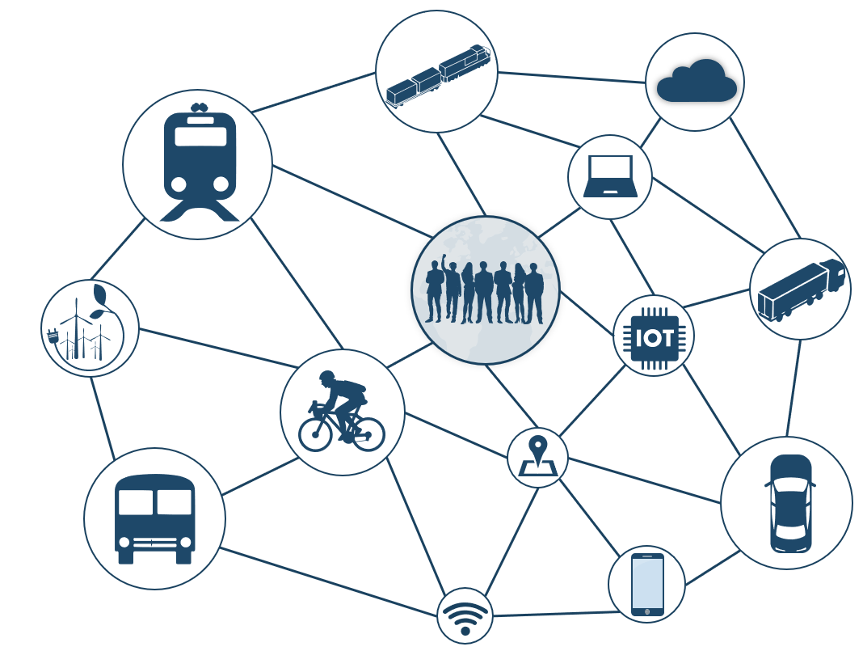

Figure 1. Conference logo

Source: [4]

Tables

Align the table title to the left, using the “Table Caption” style. Also, make sure the tables are left-aligned.

Table 1. Comparison of indicators for the period from 2019 to 2020

|  |  |  |
| --- | --- | --- |
| ***Year*** | ***Indicator 1*** | ***Indicator 2*** |
| 2019 | 546 | 567 |
| 2020 | 786 | 698 |

Source: [3]

# Mathematical equations

When mentioning numerical values in text, figures, and tables, use the following rules:

* 0.5 to express decimal numbers;
* 3,200 a comma is used to denote thousands.

When mentioning work equations, use the Insert → Equation option. The equation must be marked with a number in parentheses located along the right margin of the row in which the equation is located (1, 2, 3…), and refer to the corresponding number in the text. Just below the equation explain each of the variables used in the formula.

|  |  |  |
| --- | --- | --- |
|  | $$a^{2}+b^{2}=c^{2}$$ | (1) |

|  |  |
| --- | --- |
| Where: | a – xxx  b – xxx  c – xxx |

# Paper structure

Typically, scientific papers are comprised of the following parts [1]:

* Abstract (Abstracts provide you with a complete, but very succinct summary of the paper.)
* Introduction (An introduction should inform the reader as to what the paper is about and motivate the reader to continue reading. Also, the Introduction section should answer two questions: “What?” and “So what?” What is the paper about, and why should the reader care?)
* Methods (Describes how the results were generated. The two main objectives of the method chapter are: the reader should be given the ability to reproduce the results and the ability to judge the results.)
* Results (It is simply a presentation of the results obtained corresponding to the methods described in the previous section, organized to make them accessible to the reader.)
* Discussion (The purpose of the Discussion section is to explain the results and show how they help to answer the research questions posed in the introduction.)
* Conclusion (The Conclusions section provides a brief summary of the results and discussion, but it should be more than a summary. The goal here is to provide the most general claims that can be supported by the evidence.)
* Acknowledgments (Optional composition, intended to express gratitude and appreciation for assistance in writing the paper.)
* Literature cited

# References

When referring to references in the text of the paper, use square brackets (e.g. [2]) and a number corresponding to the number of references in the list. The citation rules are:

* When the citation refers to the idea of the entire paragraph, you place references after the point of the last sentence of the paragraph. [6]
* When the citation refers to only one thought or sentence, then mark the quotation after it (before the full stop) [7].
* When quoting a list, square brackets are marked before the colon (e.g. modal distribution includes [8] :).

When listing the papers used in the bibliography, list them as follows:

* Books and documents: Surname, Name. *Book title (Italic)*. Publisher. Place of issue. Year of issue
* Articles: Surname, Name. *Paper title (Italic)*. Journal, Volume (edition), page number in the journal.
* Internet sources: Page name. *Page title (Italic).* Available at: Page URL [Accessed: date]

1. Mack, C. A. *How to Write a Good Scientific Paper*. Spie. Washington D.C. 2018.
2. Banister, D. *The sustainable mobility paradigm*. Transport policy 15 (2), 73-80.
3. Faculty of Transport and Traffic Sciences. *Postgraduate study*. Available at: https://www.fpz.unizg.hr/web/studiji/poslijediplomski-studij [Accessed: October 08, 2020]